An Anxiety Treatment Approach That Empowers Through Skill Development
The Adaptive Anxiety Therapy Program
The Adaptive Anxiety Therapy program is an advanced CBT anxiety treatment program that focuses on helping clients to confidently adapt to the experience of anxiety rather than chase an endless cycle of anxiety symptom relief.

Stage 1: Cognitive Restructuring
Module 3: Absolute Beliefs

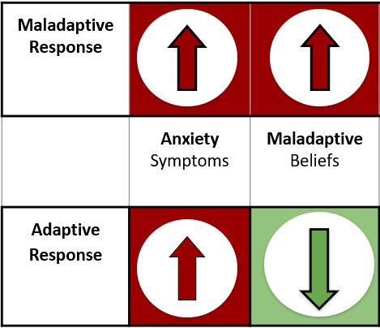

Top 10 scary Assumptions: In-Session Activity: Activity Day 1
Instructions: Review your top collected assumptions from past and current tracking. Next, narrow down all assumptions to a top 10 on the section below. These top ten scary assumptions should be assumptions that you feel trigger you the most when you experience them.
A: Answer: |  | B: Ratings
 | Scary Assumption. | Enter #
 | Scary Assumption. | Enter #
 | Scary Assumption. | Enter #
 | Scary Assumption. | Enter #
 | Scary Assumption. | Enter #
 | Scary Assumption. | Enter #
 | Scary Assumption. | Enter #
 | Scary Assumption. | Enter #
 | Scary Assumption. | Enter #
 | Scary Assumption. | Enter #
Therapist/Client Notes:
Click or tap here to enter notes.

Stop!
Quality is better than quantity. Wait 24 hours before moving to next Activity Day

Top 5 scary Assumptions: In-Session Activity: Activity Day 2
Instructions: Now narrow your top ten scary assumptions down to a top five that you feel trigger you the most when you experience them.
A: Answer: |  | B: Ratings | C: Reason for seeking Help
 | Scary Assumption. | Enter # | Reason
 | Scary Assumption. | Enter # | Reason
 | Scary Assumption. | Enter # | Reason
 | Scary Assumption. | Enter # | Reason
 | Scary Assumption. | Enter # | Reason
Therapist/Client Notes:
Click or tap here to enter notes.

Stop!
The following sections will be completed with Dr. Shawn Nabors during your next session.

Turning scarry Assumptions into Absolute Belief Systems: Therapy Session
Instructions: Next you will take each of your top scary assumptions and turn them into absolute belief systems. You will do this by attempting to find the deeper message within your scary assumption, what is it really trying to say? The more absolute and concrete, the better. This statement will represent your belief system for your selected assumption

Top Assumption #1  (Assumption) | Absolute Belief
Scary Assumption. | What’s the deeper message here?  What is this scary assumption trying to say?  Enter text.

Top Assumption #2  (Assumption) | Absolute Belief
Scary Assumption. | What’s the deeper message here?  What is this scary assumption trying to say?  Enter text.

Top Assumption #3  (Assumption) | Absolute Belief
Scary Assumption. | What’s the deeper message here?  What is this scary assumption trying to say?  Enter text.

Top Assumption #4  (Assumption) | Absolute Belief
Scary Assumption. | What’s the deeper message here?  What is this scary assumption trying to say?  Enter text.

Top Assumption #5  (Assumption) | Absolute Belief
Scary Assumption. | What’s the deeper message here?  What is this scary assumption trying to say?  Enter text.

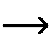

Therapist/Client Notes:
Click or tap here to enter notes.

Narrowing down top 5 absolute core belief systems: Activity Day 1
Instructions: It may be hard to believe, however, only a handful of belief systems are typically responsible for our anxiety issues. Next, you will narrow down your top 5 newly created absolute beliefs to a top 3
1. Absolute belief.
2. Absolute belief.
3. Absolute belief.
Stop!
Quality is better than quantity. Wait 24 hours before you move to the next day’s activity

