An Anxiety Treatment Approach That Empowers
The Adaptive Anxiety Therapy Approach
The Adaptive Anxiety Therapy approach is an advanced CBT anxiety treatment program that focuses on helping clients to confidently adapt to the experience of anxiety rather than chase an endless cycle of anxiety symptom relief.

Stage 3: Exposure Training
Module 7: Identifying Exposure Situations

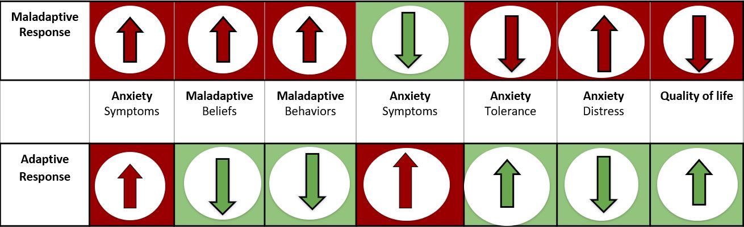

Documenting Anxious Situations: Activity Day 1
Instructions: A: Finally, you will document below all your identified situations used for your homework tracking. B: you will then rate/guess how distressing each situation was to you on a distress scale of 0-10, 0=not distressing at all, 10=absolutely distressing. Documenting these situations will help you and Dr. Nabors create exposures later in the treatment program.

A: Situation: |  | B: Distress Level  0 = Not Distressing: 10 = Absolutely Distressing | Selected for future exposure idea
 | Situation. | Enter # | ☐Yes
 | Situation. | Enter # | ☐Yes
 | Situation. | Enter # | ☐Yes
 | Situation. | Enter # | ☐Yes
 | Situation. | Enter # | ☐Yes
 | Situation. | Enter # | ☐Yes
 | Situation. | Enter # | ☐Yes
 | Situation. | Enter # | ☐Yes
 | Situation. | Enter # | ☐Yes
 | Situation. | Enter # | ☐Yes
 | Situation. | Enter # | ☐Yes
 | Situation. | Enter # | ☐Yes
 | Situation. | Enter # | ☐Yes
 | Situation. | Enter # | ☐Yes
 | Situation. | Enter # | ☐Yes
 | Situation. | Enter # | ☐Yes
 | Situation. | Enter # | ☐Yes
 | Situation. | Enter # | ☐Yes

Therapist/Client Notes:
Click or tap here to enter notes.

Stop!
Quality is better than quantity. Wait 24 hours before you move to the next day’s activity.

Identifying Exposure Situations: Activity Day 2
Instructions: Acceptance focus helps you to commit to your opposite actions by becoming more flexible to your anxiety rather than fighting it. Below, you will identify any physical sensations that bothered you during the anxious situation.
Level of anxiety for situation 1-10 Panic Scale 1=low anxiety 10=panic attack |  | Situation (shorthand) | Selected for future exposure idea
High | Anxiety Situation 10: | Situation. | ☐Yes
High | Anxiety Situation 9: | Situation. | ☐Yes
High | Anxiety Situation 8: | Situation. | ☐Yes
Medium High | Anxiety Situation 7: | Situation. | ☐Yes
Medium | Anxiety Situation 6 | Situation. | ☐Yes
Medium | Anxiety Situation 5: | Situation. | ☐Yes
Low Medium | Anxiety Situation 4: | Situation. | ☐Yes
Low | Anxiety Situation 3: | Situation. | ☐Yes
Low | Anxiety Situation 2: | Situation. | ☐Yes
Low | Anxiety Situation 1: | Situation. | ☐Yes
Therapist/Client Notes:
Click or tap here to enter notes.

Stop!
Quality is better than quantity. Wait 24 hours before you move to the next day’s activity.

Exposure Hierarchy: Activity Day 3
Instructions: Acceptance focus helps you to commit to your opposite actions by becoming more flexible to your anxiety rather than fighting it. Below, you will identify any physical sensations that bothered you during the anxious situation.
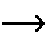
Level of anxiety for situation 1-10 Panic Scale 1=low anxiety 10=panic attack | Situation (shorthand)
High Anxiety Situation  Hard  (9-10) | Situation.
High Anxiety Situation  Difficult  (7-8) | Situation.
Medium Anxiety Situation 3:  Somewhat Difficult  (5-6) | Situation.
Low Anxiety Situation:  Somewhat Easy  (3-4) | Situation.
Low Anxiety Situation:  Easy  (1-2) | Situation.

Therapist/Client Notes:
Click or tap here to enter notes.

Stop!
Excellent job! You have completed this module. Be prepared to discuss this module
in depth with Dr. Nabors during your next therapy appointment.

